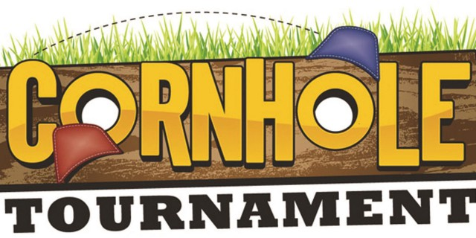

Saturday, September 9th
- Tournament limited to 32 teams
- Pick your own partner
- $40/team
- 70% payout for 1st, 2nd & 3rd places

Pre-Registration Contact:  Lorie Blythe 317-501-2298  James Hunter 317-997-3506  Adrienne Long 317-850-7465 | Same Day Registration:  9:30am-10:45am @ Class Act Hair Studio  55 S Chestnut St, Monrovia
Pre-Registered Teams: Check in by 10:30am

Team Members:

Print Names__________________________&___________________________

Cell Phone #__________________________&___________________________

Wish to compete in Monrovia Festival Cornhole Tournament. Team members agree to the $40 Entry Fee, the Rules & Regulations (posted on day of tournament and on https://www.facebook.com/MonroviaFestivalAndCivicAssociation & http://indianamonroviafestival.weebly.com).

Team Members Signatures:

____________________________________&__________________________________

*No Refunds unless inclement weather

GOOD LUCK! LET’S THROW SOME BAGS!
