John Deere 5045 E
Tractor Give-A-Way
This is a NEW 45 hp tractor
with loader
If you choose not to take the tractor, you can take the $14,000 cash reward option!!!
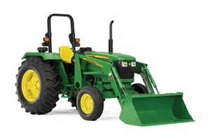
$100.00 per ticket
Only 450 tickets will be sold
There will be other cash prizes awarded during the drawing.
Drawing will be Saturday, September 9 @ 3:00
All profits go toward the Monrovia Festival

